DATA COLLECTION
A python based WIFI data collection script is used to collect the required data from Aps around the FENS, L-floor. We captured MAC Address, ESSID, Frequency, Bit Rate, Signal Level and timestamp from the Aps. The experiment was repeated for 10 adjacent rooms, as indicated in the figure below. In every room, data collection was conducted for 5 minutes, with the resolution of ~50 data points/s. During this time, location of the data collection device was in constant motion, going around the room in homogeneous fashion. This step allowed the experiment to be conducted more scientifically. For L045, given its sheer size, data collection was conducted for 10 minutes, instead of the usual size. At the end, a dataset of ~17000 data points was created. For the training and testing, two different approaches were employed: A single data point based training and a frame based training. In the frame case, these data points are bundled together to mitigate False Positive Rate problem, by creating a single frame that consists of N(such as 10) datapoints that belong to the same label.

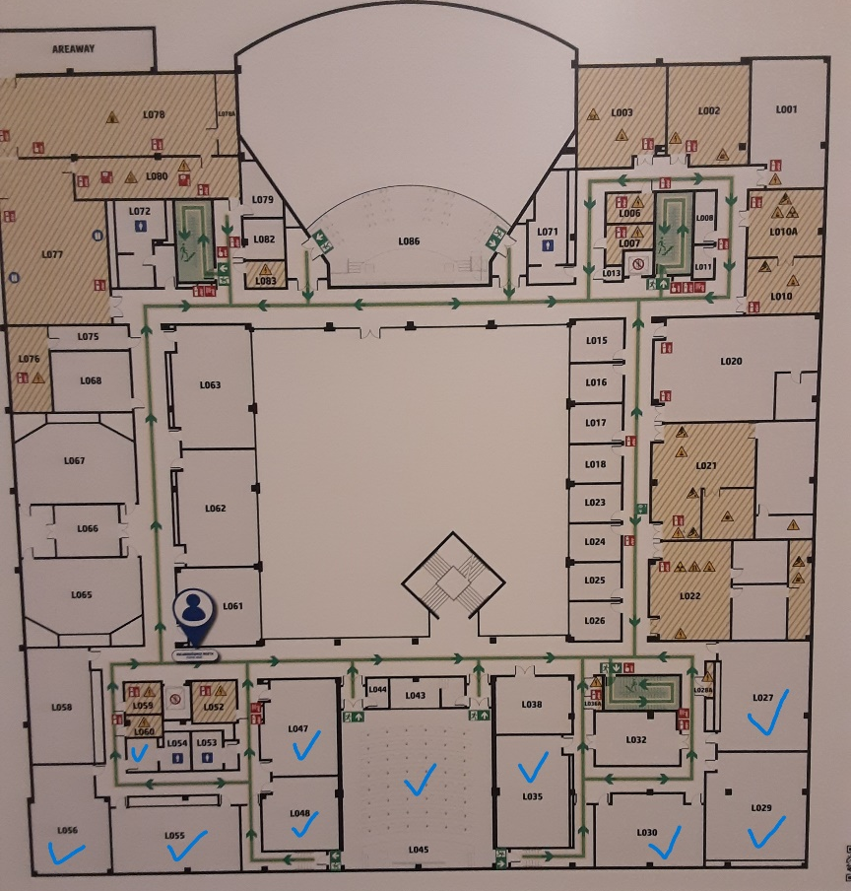

Before training the Deep Neural Network (DNN), we experimented with other models like Random Forest, K-Nearest Neighbors, Logistic Regression, Decision Tree and SVM. These models were tested for their ability to classify the room based on WiFi data. Their initial scores were pretty low so we tried to optimize them by finding optimal parameters with hyperparameter tuning. We also tried other optimization techniques such as cross validation and more with their respective models, you can see the best results we could get with these models.

Results for Random Forest (Best Params: {'n_estimators': 200}):
Accuracy: 0.59
Precision: 0.59
F1 Score: 0.59
----------------------------------------
Results for K-Nearest Neighbors (Best Params: {'n_neighbors': 7}):
Accuracy: 0.55
Precision: 0.55
F1 Score: 0.55
----------------------------------------
Results for Logistic Regression (Best Params: {'C': 1}):
Accuracy: 0.19
Precision: 0.16
F1 Score: 0.15
----------------------------------------
Results for Decision Tree (Best Params: {'max_depth': None}):
Accuracy: 0.59
Precision: 0.59
F1 Score: 0.59
----------------------------------------
Results for Support Vector Machine (SVM) (Best Params: {'C': 10, 'kernel': 'rbf'}):
Accuracy: 0.48
Precision: 0.52
F1 Score: 0.47
----------------------------------------
Then we trained a DNN model. The DNN has layers with neurons that process the data. It starts with 128 neurons, then 64, then 32, and finally, an output layer predicts the room. Dropout is used between layers to prevent overfitting, and the model uses a softmax function in the output layer to decide the most likely room. The input data is standardized to make it easier for the model to learn patterns. The model is trained on 80% of the data, while 20% is reserved for validation during training. You can see the results below:
Test Accuracy: 0.88
Test Precision: 0.83
Test F1 Score: 0.84

